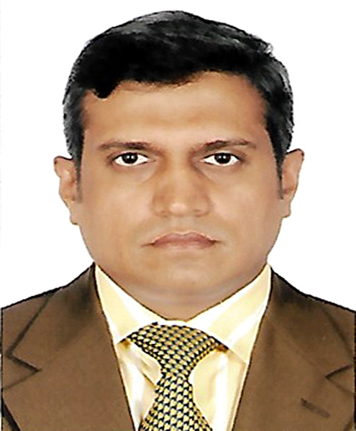
Resume of
Mir Ahamed Hossain
Mobil: 01711531091

CAREER OBJECTIVE:

I am highly desired to work in a place where I shall be able to explore my capabilities and gradually develop knowledge, skill and abilities to perform duties and responsibilities efficiently and effectively to add values to your organization where I will find ample scope and opportunity to promote to a significant position.
EDUCATION QUALIFICATION:

Asian University of Bangladesh, Dhaka

Masters
Subject : Human Resource Management
Year : 2013
CGPA : 2.917 (Out of 4)

International Tourism Institution Switzerland,

Post Graduate
Subject : Tourism Management
Year : 2002
CGPA : Academic Grade- D, Professional Attitude Grade-B

Bachelor of Business Administration (BBA), Dhaka
Asian University of Bangladesh,
Group : Marketing
CGPA : 3.05 (Out of 4)
Passing Year : 2001

Higher Secondary Certificate (HSC)
Institute : Dhaka City Collage
Group : Commerce
Division : 1st
Passing Year : 1997

Secondary School Certificate (SSC)
Institute : Wari High School
Group : Commerce
Division : 1st
Passing Year : 1995

COMPUTER TRAINING

I have basic experience in Modern office management & Computer application.

EXPERIENCE:

Name of the Company: Hi-Tech Electrical Industries Pvt. Co. Ltd.
Office Address : 9/5 Nabab Steet Wari, Dhaka-1203
Factory : Matuwail Konopara, Arabri Road, Demra, Dhaka.
Position : Executive Officer
Nature of Business : Cables Manufacturer & Suppliers
Duration : 2007 to 2017

Name of the Company: M/S Solar Trade
Office Address : 9/5 Nabab Street Wari, Dhaka-1203
Nature of Business : Solar Home System Supplier
Duration : Till Now.

COMPUTER SKILL:

- System soft: Microsoft Windows
- Application soft: Microsoft office (MS Word, MS Excel, MS Power Point, Internet Browning.
LANGUAGE SKILL:

- English: Good Listening, Writing & Speaking Ability.
- Good Speaking Capability in English Language.

PERSONAL INFORMATION:

Name : Mir Ahamed Hossain

Father’s Name : Late Mir Altaf Hossain

Mother’s Name : Shamsun Nahar Mir

Date of Birth : 01/12/1979

Nationality : Bangladeshi

Nationality ID : 6419650293

Blood Group : B⁺ (Positive)

Marital Status : Married

E-mail : meerswiss554@yahoo.com

Present Address : House # 125, Road # 04, Block # A,
Apt# A, Banani, Dhaka-1213.

Permanent Address : House # 125, Road # 04, Block # A,
Apt# A, Banani, Dhaka-1213.



Signatue
Date :08/08/2020

